Logbook 3
Name: | Jovian Lim Zheng Yuan
Week Date: | Part A -Meeting 3 of 8
(The above information is for you to keep track of which week this log is applicable for. This information is not required in the online logbook as the system will find your name, your supervisor’s name, and take the submission date, automatically. You must submit the online log in the relevant week. Logs cannot be backdated to missed weeks.)

Meeting date:  (please note if no meeting is planned this week) | Date and day  2 July 2026, Thursday
Work Undertaken this week:  Not more than 500 words | From the last meeting until now, what have you done based on the task you have listed in the last logbook?  - I had research on the how the dc motor can be converted to a suction, with the research I did the component that converts to an suction is through an impeller fan. There are mainly 3 types of it ( straight, curve and slan curve)  - I had a clearer understanding on how many python files can link to run them all in one file. Haven’t tested in visual code but will test  - Did a small research on slam how it works and how it been used with a lidar scanner  - I did some research on slam integration and I found there’s a baby ros that can help with python coding that is open source and wont be narrow down.
Problems encountered:  (Not more than 500 words | What are the tasks that are still outstanding to write your Project Outline  - First: impeller will be printed in pla and need to get the dimension since is not for the market it doesn’t need to print for heat resistant but petg will be great to print  - Second: yet to test the python files only researching how the connection works  - Plan out the wiring connections for the system if possible will do in schematic diagram  - yet to check how raspberry pi can link with arduino  - The dimensions of the body and weight issue havent been checked
Tasks agreed for upcoming week before the next meeting | What are your plan actions/task until the next progress meeting that are agreed with your supervisor  - Prepare draft project outline with details  - Prepare draft project resource check list  - Research on cnn classifer to identifier the floor and dirt particle  - Test out the pyhton codes to see how they work  - Research on how the app can communiocate and watch the robot cleaning progress and control the robot
Figures:  (Upload image files in the online Log Form, but feel free to keep notes here about which images you intend to upload. Use “Figure Caption” information as the filenames, e.g., “Figure 1 – A screenshot of the initial constrained Sketch in CATIA.jpg”) | - Update Hardware Block diagram of your system  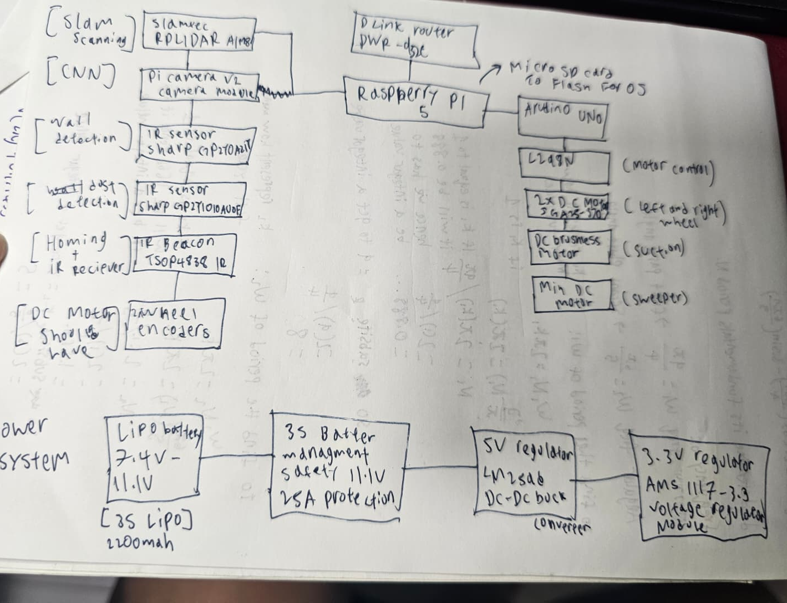  Figure 1: updated block diagram with components parts  - Key software codes/modules that need to be developed  There will be multiple codes to integrate into this project like such as to call out the hardware, navigation, ai logical thinking and for app communication plus some are utilities code for the backend. Below I  have split them to groups  • Hardware - lidar.py its to call the lidar out to get the distance and views - motor.py control the motor speed and direction -camera.py calls the camerause for cnn -beacon.py for homing when it needs to recharge or go home - Sensors.py reads the sensors, battery voltage, obstacle avoidance -odmetry.py mainly for reading the encoder cycles and show the axis  of the robot  • Navigation -Slam.py updated the map from the lidar scanning plus odmetry -path-planner.py it generates the path to clean from the map -Obstacle Avoidance.py for wall avoidance -controller.py to track the robot between point to point  • AI aspects  -surface_classifier.py identify the tiles on the floor appearance like  carpet or wood or others  -dirt_detector.py sees dirt/dust on maps and marks as dirt section  -suction_control.py controls the power of the motor based on the  floor type  -train_classifier.py trains the model  • App codes  - Server.py for map logging - Mqtt_cilent.py for map updates - Map-encoders to convert numpy to json file for display - Session_logger.py save all logs and history of clean history  • Utilities  - Visualizer.py display the map on the app - Logger.py in the terminal - Simulator.py testing the programme to see hows the lidar work  with - Arduino_flasher.py communicate with raspberry  - Any Quality and Regulatory issues addressed?  Quality:  1. mechanical safety since theres moving parts like brushes and roller guard, finger or pet wont get caught in between  2. Electrical safety to protect short circuit, over charge and cell balancing protection for BMS, proper wire gauges to prevent wire heatings, Lipo battery casing so it can be kept safety, flame retardant  3.Thermal and overheating management: lipo battery may get overcharge so adding a battery management system will cut the power before it overheats. Include temperature sensors to monitor the motor heat, and shut it down when is too hot.  Regulatory:  1. Product safety, indicating the safety mark for consumer protection , since vacuum uses the main power hence is needed to add  2. Camera/ data privacy : PDPA (personal data protection act 2012) the camera captures the house hence this has the be address since is use for mapping and all, plus people can get captured in the camera  3. Battery fire safety act SS 638 , I will be using a lipo battery and need to be properly labeled so it wont cause others issue  - A updated/improved version of your system sketch  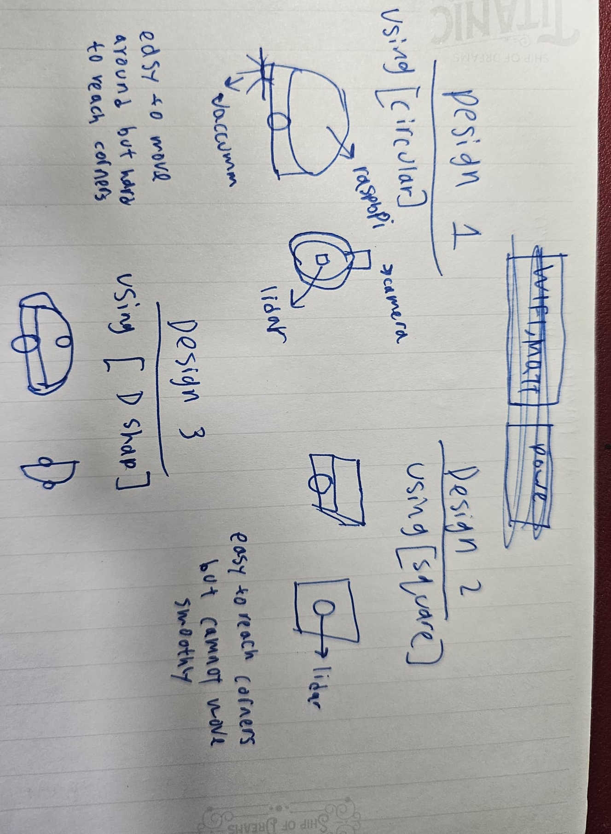  Figure 2: system sketch (yet to change)
References: | References used for quality and regulatory  IEC 60335-2-2 — Household vacuum cleaners (electrical safety)  IEC 62133 — Lithium battery safety  ISO 10218 / ISO 13482 — Robotics safety (ISO 13482 covers personal care robots, very relevant for a home robot)  FCC / CE marking — For Wi-Fi/Bluetooth modules used in the robot

